INFORMATION NOTE
For
the Register of Damages for Ukraine

The Ministry of Foreign Affairs informs about the promotion of the Register of Damages for Ukraine and the establishment of an International Commission for Compensation.
The Register of Damages, created within the Council of Europe in 2023, collects evidence and claims regarding losses and damages caused by the aggression of the Russian Federation against Ukraine, starting with February 24, 2022. Romania participates in this mechanism based on Law no. 75/2024.
An independent international Commission is being established that will analyze and decide on compensation claims.
For additional information and to register in the Register of Damages for Ukraine, you can access the QR code.

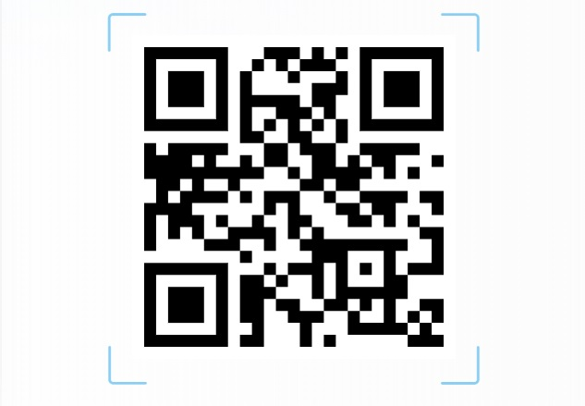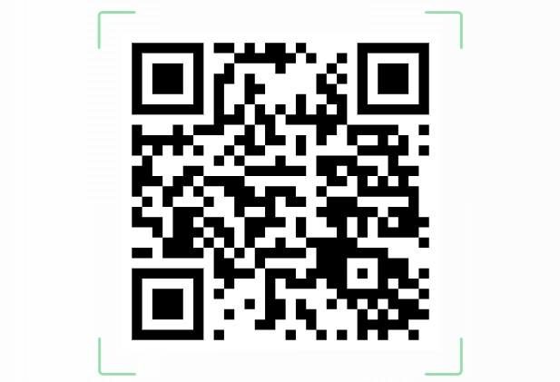

English language Ukrainian language

